**What Is Probability Without Replacement Or Dependent Probability?**

In some experiments, the sample space may change for the different events. For example, a marble may be taken from a bag with 20 marbles and then a second marble is taken **without replacing** the first marble. The sample space for the second event is then 19 marbles instead of 20 marbles.

This is called probability without replacement or dependent probability. We can use a tree diagram to help us find the probability without replacement.

**How To Find The Probability Without Replacement Or Dependent Probability?**

Step 1: Draw the Probability Tree Diagram and write the probability of each branch. (Remember that the objects are not replaced)  
Step 2: Look for all the available paths (or branches) of a particular outcome.  
Step 3: Multiply along the branches and add vertically to find the probability of the outcome.

**Example:**  
A jar consists of 21 sweets. 12 are green and 9 are blue. William picked two sweets at random.  
a) Draw a tree diagram to represent the experiment.

b) Find the probability that  
i) both sweets are blue.  
ii) one sweet is blue and one sweet is green.

c) William randomly took a third sweet. Find the probability that:  
i) all three sweets are green?  
ii) at least one of the sweet is blue?

**Solution:**  
a) Although both sweets were taken together it is similar to picking one sweet and then the second sweet without replacing the first sweet.

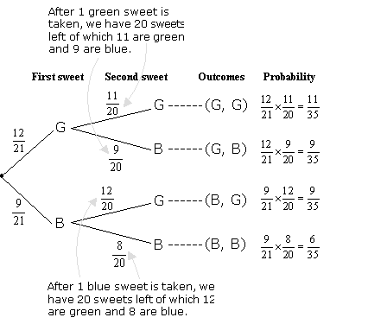

Check that the probabilities in the last column add up to 1.  
  
  https://www.onlinemathlearning.com/image-files/clip_image013_0001.gif

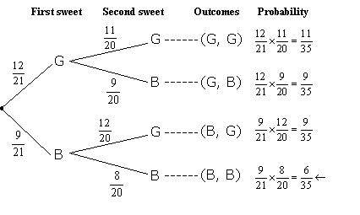

b) i) P(both sweets are blue) = P(B, B)  
  https://www.onlinemathlearning.com/image-files/clip_image017_0000.gif  
  
  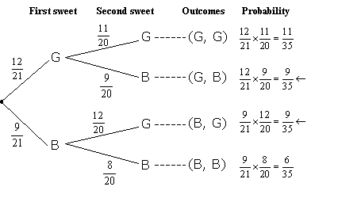

ii) P(one sweet is blue and one sweet is green) = P(G, B) or P(B, G)

https://www.onlinemathlearning.com/image-files/clip_image022_0001.gif

c) i) P(all three sweets are green) = P(G, G, G)

https://www.onlinemathlearning.com/image-files/clip_image024_0001.gif

ii) P(at least 1 sweet is blue) = 1 – P(all three sweets are green)  
  https://www.onlinemathlearning.com/image-files/clip_image026.gif